Usage Statistics for snydersstoughton.com
Summary Period: Last 12 Months
Generated 18-May-2009 01:03 EDT

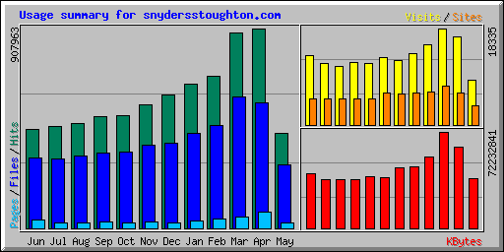
Summary by Month
Month | Daily Avg |  |  |  | Monthly Totals
Month | Hits | Files | Pages | Visits | Sites | KBytes | Visits | Pages | Files | Hits
May 2009 | 23932 | 16107 | 1259 | 477 | 3695 | 37068411 | 8591 | 22675 | 289927 | 430784
Apr 2009 | 30265 | 19052 | 2481 | 555 | 6066 | 60482274 | 16660 | 74450 | 571573 | 907963
Mar 2009 | 28633 | 19299 | 1731 | 591 | 7479 | 72232841 | 18335 | 53662 | 598272 | 887653
Feb 2009 | 24733 | 16679 | 1458 | 541 | 6225 | 53205707 | 15159 | 40840 | 467030 | 692548
Jan 2009 | 21206 | 13882 | 1070 | 438 | 6016 | 46379717 | 13597 | 33188 | 430348 | 657401
Dec 2008 | 19576 | 12551 | 841 | 395 | 5914 | 45176554 | 12263 | 26088 | 389097 | 606880
Nov 2008 | 18680 | 12594 | 963 | 428 | 6160 | 37718591 | 12857 | 28906 | 377841 | 560426
Oct 2008 | 16491 | 11145 | 850 | 378 | 4913 | 38572479 | 11723 | 26365 | 345521 | 511234
Sep 2008 | 16940 | 11408 | 913 | 396 | 4927 | 36295908 | 11898 | 27419 | 342256 | 508218
Aug 2008 | 15324 | 10543 | 759 | 356 | 4874 | 36485561 | 11057 | 23551 | 326833 | 475048
Jul 2008 | 14976 | 10118 | 825 | 379 | 4961 | 36561538 | 11759 | 25592 | 313679 | 464268
Jun 2008 | 15001 | 10662 | 1247 | 438 | 4879 | 40571509 | 13164 | 37433 | 319874 | 450039
Totals |  |  |  |  |  | 540751090 | 157063 | 420169 | 4772251 | 7152462

Generated by Webalizer Version 2.01

